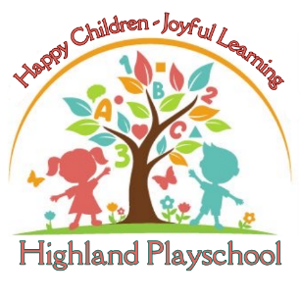
Highland Playschool
Application for Admissions
13342 Clarksville Pike ● Highland, MD 20777 ● Phone: (301) 778-1020

Desired Start Date: ____/____/_____
(Enrollment date reflects date in which child will start at Highland Playschool and/or when tuition payments will begin)

Child’s Name (Last, First & Middle Initial): _______________________________________________________________

Child’s Nickname: _________________________________ Child’s Birthday: _____/_____/______

Child & Parent(s) Address: ___________________________________________________________________

Child’s Living Arrangements: ___________________________________________________

Child’s Legal Guardian(s): ____________________________________________________________

Does your child have any allergies, special needs, including but not limited to IFSP/IEP: □ Yes □ No
If yes, please provide details: ____________________________________________________________________

Parent #1 Name: _______________________________ Cell Number: ( )________________________

Parent #1 Employer: _____________________________ Work Number: ______________________________

E-mail Address: ____________________________________________ Work Hours: ________________________

Parent #2 Name: _______________________________ Cell Number: (______) ________________________

Parent #2 Employer: _____________________________ Work Number: _______________________________

E-mail Address: ___________________________________________ Work Hours: ____________________

Additional information regarding your child: _____________________________________________________________
__________________________________________________________________________________________________
__________________________________________________________________________________________________

OFFICE USE ONLY ----------------------------------------------------------------------------------------------------------------------------------------

Wait list fee paid: _____ Check: ____ Check#: __________ Card:_____

